

|  |
| --- |
| The Battle of Neighborhoods |
|  |
| October 19  CAPSTONE PROJECT  Authored by: Liliya Lychkovski |

Introduction

Business Problem

A Health Care Insurance company is concerned with an increasing number of people with alcohol and drug dependencies year over year. They would like to understand if in addition to socioeconomic factors (education, income and occupation) – proximity to places that sell alcohol is a contributing factor as well.

Data

One way of solving the problem is to look at Inpatient Charge Data provided by Centers of Medicare and Medicaid Services.

<https://www.cms.gov/Research-Statistics-Data-and-Systems/Statistics-Trends-and-Reports/Medicare-Provider-Charge-Data/Inpatient2011.html>

The data provided here include hospital-specific charges for more than 3,000 U.S. hospitals that receive Medicare Inpatient Prospective Payment System (IPPS) payments for the top 100 most frequently billed discharges, paid under Medicare based on a rate per discharge using the Medicare Severity Diagnosis Related Group (MS-DRG) for Fiscal Year (FY) 2011.

We will only include data with DRG 897 – ALCOHOL/DRUG ABUSE OR DEPENDENCE W/O REHABILITATION THERAPY W/O MCC and Provider State MN - Minnesota. Then, in combination with the Foursquare location data we will compare the neighborhoods of two analogous cities with the highest and lowest discharge rate for DRG 897, and determine how similar or dissimilar their neighborhoods are. We will learn if one city has more venues (e.g. bars, liquor stores) that sell alcohol then the other.

Methodology

For the purpose of this analysis, we start by reviewingInpatient Charge Data provided by Centers of Medicare and Medicaid Services. Although, big metropolitan cities like Minneapolis and St Paul always stand out due to the size of population that resides there, we’ll focus our attention on suburban cities.

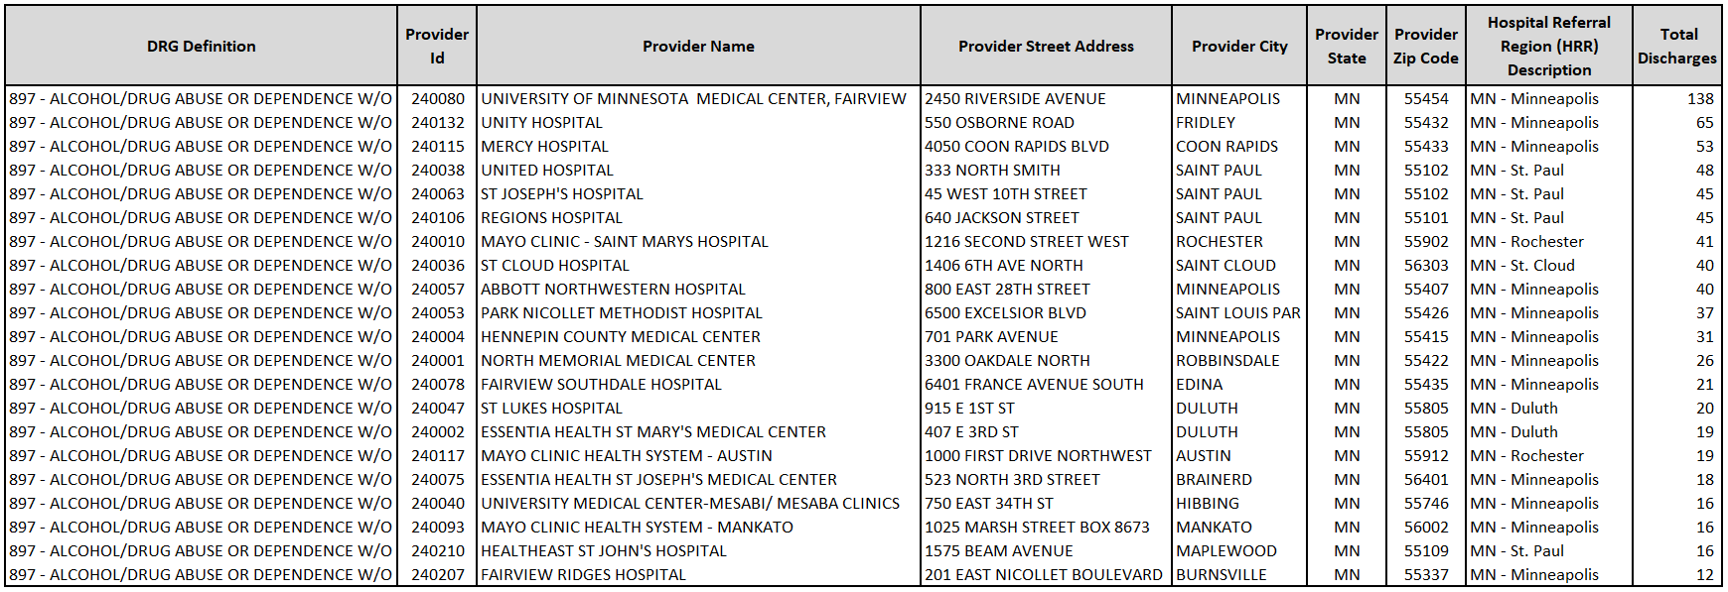

Figure 1. DRG Summary for Medicare Inpatient Prospective Payment Hospitals, FY2011

To verify the two cities with highest and lowest discharge rate for DRG 897, in our case a city of Fridley (northern Minneapolis suburb) and a city of Burnsville (southern Minneapolis suburb), are comparable and suitable for our study - we will reference US Census data.

<https://www.census.gov/search-results.html?searchType=web&cssp=SERP&q=Burnsville%20city,%20MN>

<https://www.census.gov/search-results.html?q=Fridley&page=1&stateGeo=none&searchtype=web&cssp=SERP&_charset_=UTF-8>

Indeed, these are two suburban cities, that are located within 15 miles north and south of downtown Minneapolis in the State of Minnesota.

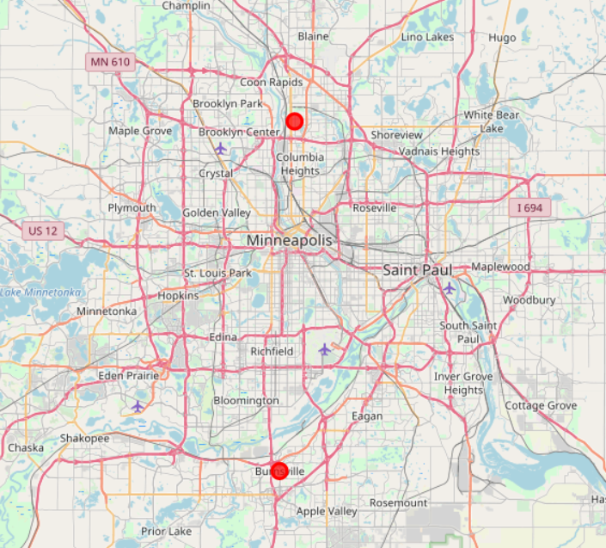

Fridley is a “first ring” or “inner ring” suburb in the northern part of the Twin Cities, and has a total area of 10.89 square miles.

Burnsville is situated on the south bank of the Minnesota River and considered a “second ring” suburb of the Twin Cities. The city has a total area of 26.93 square miles.

Demographic data provided by US Census Bureau give us a better understanding about the population and economic development of the cities.

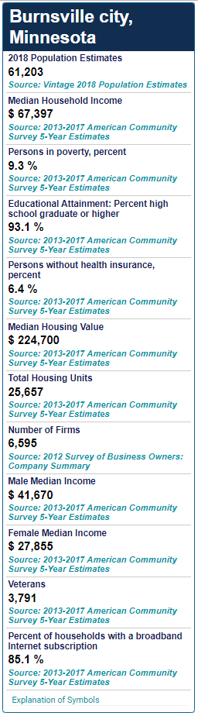 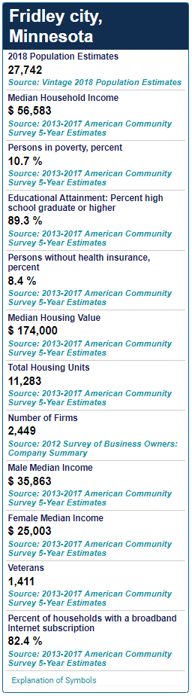

Figure 2. U.S. Census Bureau QuickFacts

The exhibit above illustrates that Burnsville is larger (by size and population) and a little bit more prosperous than Fridley. However, we still believe, given their geographical location and demographics, the two cities are very comparable.

Now we will use Foursquare location data to study the neighborhoods of two analogous cities with the highest and lowest discharge rate for DRG 897, and determine how similar or dissimilar their neighborhoods are. We will learn if one city has more venues (e.g. bars, liquor stores) that sell alcohol then the other.

To accomplish this, we will use the geolocator function of Nominatim to find the geo coordinates of Burnsville and Fridley. Then we will use latitude and longitude of each city to pull the venues in the 5000-meter radius.

The query returned 97 venues for Burnsville and 100 venues for Fridley, with 97 unique categories overall.

Next, we’ll analyze each neighborhood and calculate the mean of the frequency of occurrence of each category. Then print each neighborhood along with the top 20 most common venues.

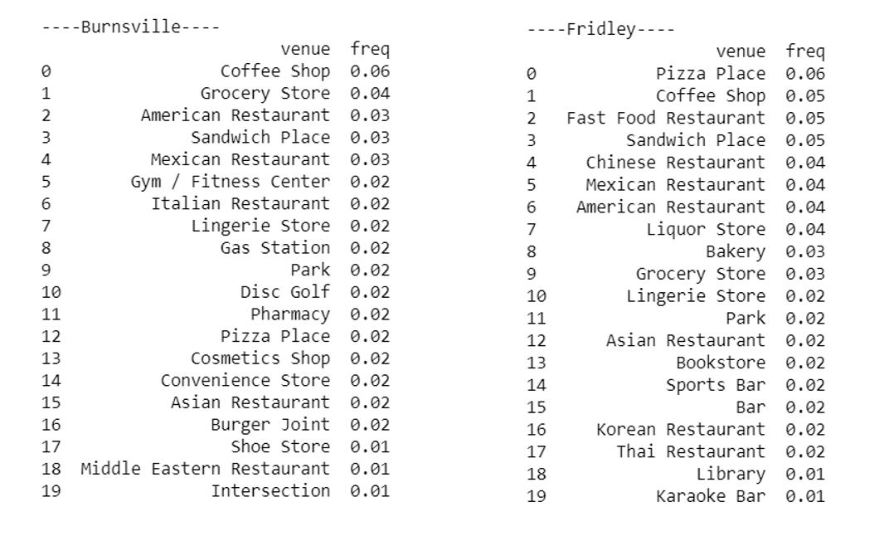

**Figure 3. Top 20 most common venues**

Results

Indeed, we learned one city has more venues (e.g. bars, liquor stores) that sell alcohol then the other.

Let's display the top 10 most common venues for each neighborhood/city:

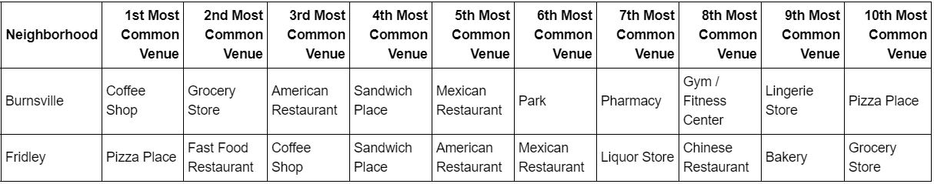

**Figure 4. Top 10 most common venues**

From the figure above we can see the “Liquor Store” is ranked 7th most common venue in Fridley, yet Burnsville has no “Liquor Store” among the top 10 most common venues observed.

When we refer to the previous display of top 20 most common venues, we find there are several bar venues (“Sports Bar”, “Bar” and “Karaoke Bar”) among the most common venues in Fridley, and no such venues in Burnsville.

The “Liquor Store” venue in Fridley has a mean frequency of occurrence 0.4. In Burnsville the same 0.4 frequency of occurrence has “Grocery Store” which is ranked 2nd most common venue.

It’s also worth mentioning that Burnsville has “Park” and “Gym/Fitness Center” among its top 10 most common venues, whereas in Fridley the top 10 most common venues consist of food and beverage places such as restaurants, coffee shops, a grocery store and a liquor store.

**Discussion**

In an effort to help health care insurance company answer the question whether proximity to places that sell alcohol can be a contributing factor to positive trend of alcohol dependency cases among their members in Minnesota, we have identified two suburban cities in metropolitan area of Minneapolis with the highest and lowest discharge rate for DRG 897 – ALCOHOL/DRUG ABUSE OR DEPENDENCE W/O REHABILITATION THERAPY W/O MCC. Then, we studied the population of two cities to determine whether it’s comparable and can be used in our analysis to answer the question. We decided that given geographical locationand demographics of Burnsville and Fridley, the two cities are very comparable.

We utilized Foursquare location data to study the neighborhoods of chosen cities and learn what the most popular venues are. Indeed, the analysis revealed that the city of Fridley had Liquor Store as the 7th most common venue, as well as various bars in the top 20 most common venues category. The city of Burnsville had none.

**Conclusion**

Perhaps, the discharge data used in the analysis can be called outdated, we still believe the findings outlined here are important. Our analysis confirms the hypothesis that in addition to socioeconomic factors (education, income and occupation) – proximity and easy access to places that sell alcohol contribute to the rate of consumption, and therefore alcohol addiction.

Medical health data are not readily available and often contain protected PHI. Therefore, the insurance company is advised to conduct its own analysis utilizing member health data to study their population and environmental influence on it. Medical health insurance company can partner with cities to address its concerns about increasing number of people with alcohol and drug dependencies year over year for the city’s population and call to implement the measures to limit the access to alcohol.